|  |  |  |  |  |  |
| --- | --- | --- | --- | --- | --- |
| Date | December 12, 2022 | | | Tester Name | Syed Shahabuddin |
| Environment | Penfax - Test | | | Login used |  |
| Operating System | Select OS | Version: | Update: | | |
| Software Used | Select Software | Version: | Update: | | |
| Select Software | Version: | Update: | | |
| Release version | 22.4.1 | | | | |
| Title | E23.15 | | | | |
| Test Type | Regression | | | | |
| Test Scenario | PEPP Age 71 Letters (Member and Employer) | | | | |
|  |  | | | | |
| Expected Results | Verify the batch run successfully and letters generated and saved on member communications  Single PDF should generate with all letters.  Possible items to test once letter is fixed: Run query with all members who turn 71 in calendar year and active with ER & spot check to make sure they are all on list. Not sure how it handles anyone with multiple ER’s and 71. Are deferred members on this list or is that another letter?  existing known defects -4436 ,4803,5795 | | | | |
| Pass/Fail | Pass | | | JIRA# | N/A |

Set to run tomorrow morning:

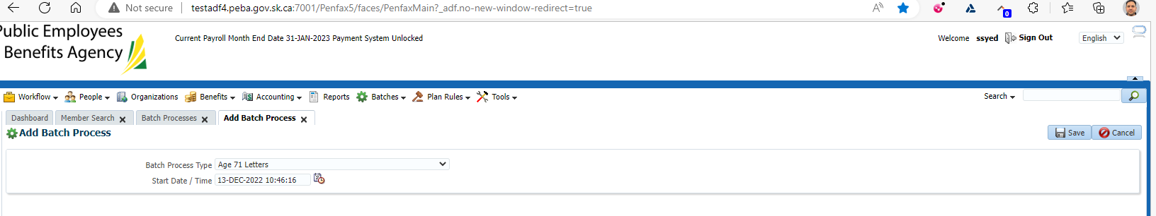

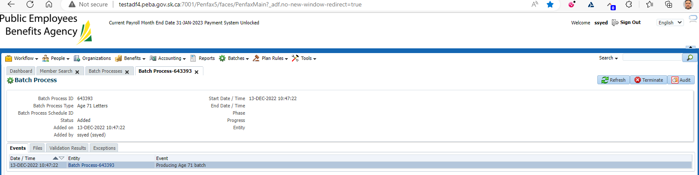

Batch ran successfully:

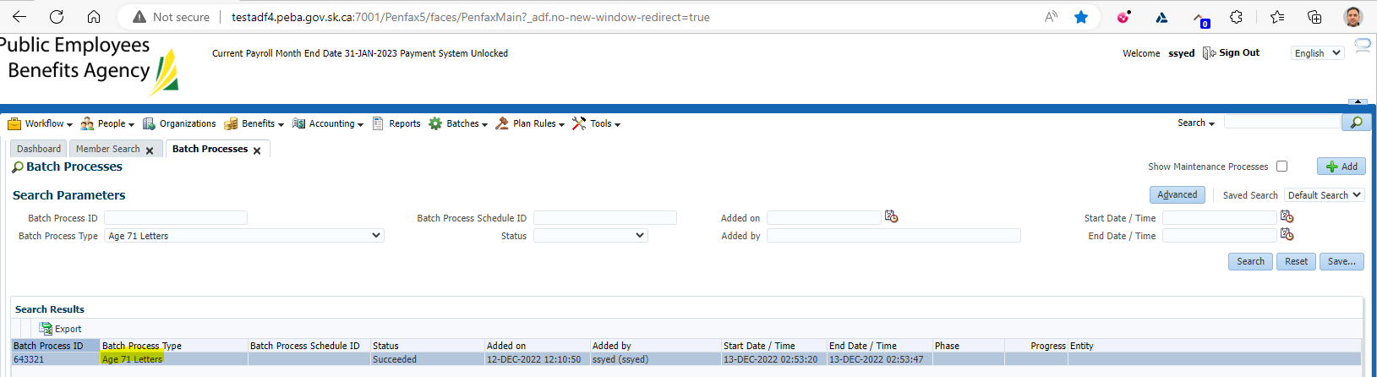

No further verification required, there are outstanding tickets with the letters. Janette is the expert on these issues.